**NST41092 Practical for Secure Network Infrastructure**

Continuous Assessment 1

Submission date 30/11/2022

Submission guideline:

Mark your registration numbers clearly in your assessment files and forward it to

razmik@gmail.com with the subject “NST41092 assessment1 - <your registration number>” on

or before the deadline.

Prepare a sample network as shown in Packet Tracer networking simulation tools.

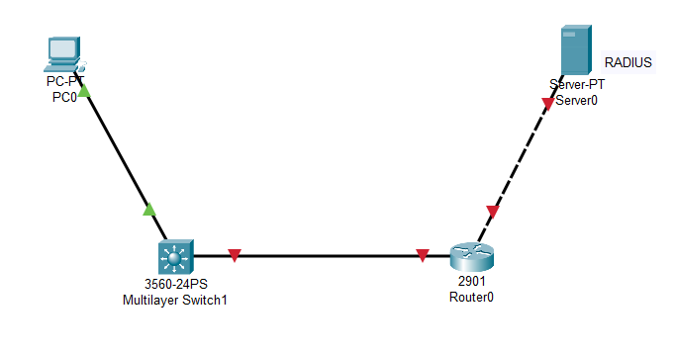

• Set the hostname of the router as Router_<last three digits of your registration number>

(E.g. Router_029 )

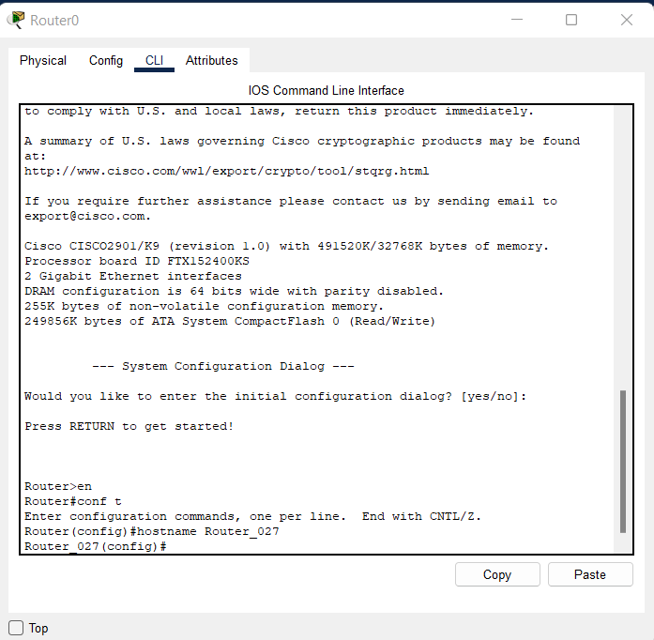

• Set the hostname of the switch as switch_<last three digits of your registration number>

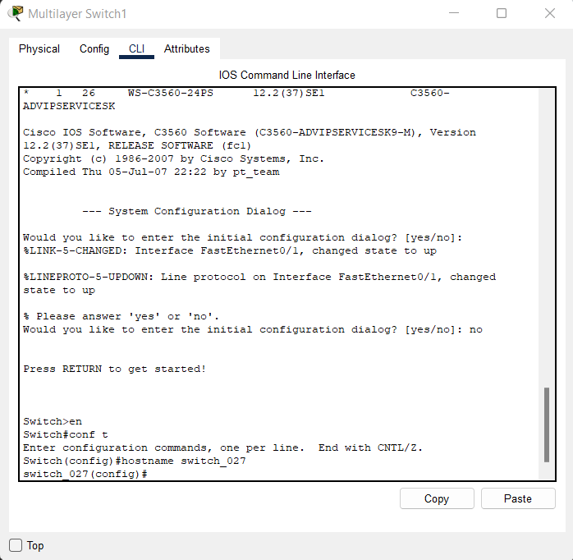

• PC – IP address 192.168.10.20 Default gateway 192.168.10.1

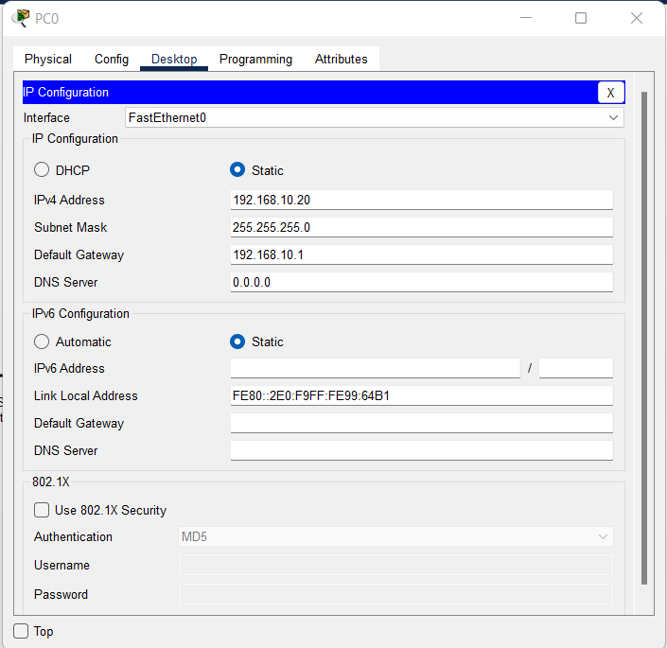

• Server IP address 192.168.20.20 Default gateway 192.168.20.1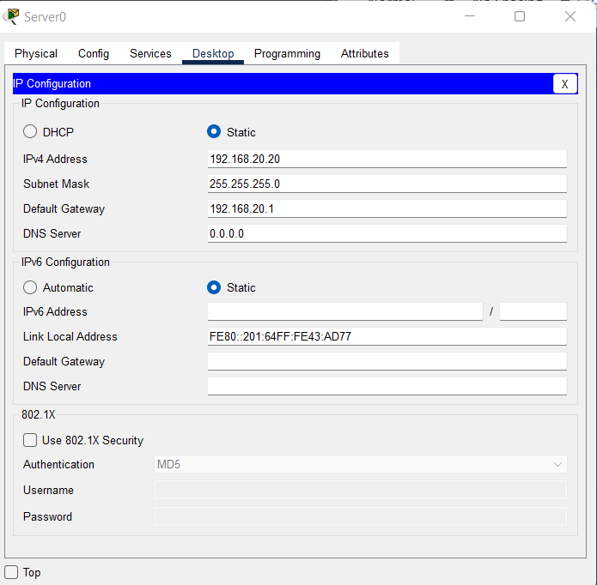

• Configure the default gateway addresses 192.168.10.1 and 192.168.20.1 in the router

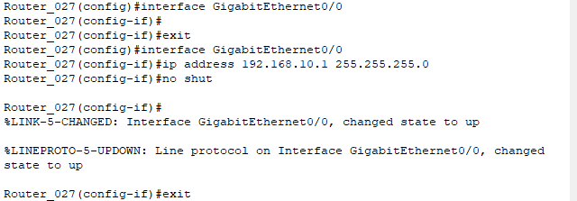

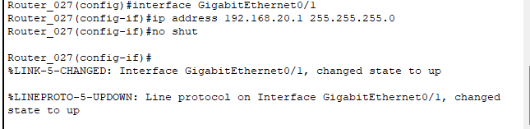

a. Configure a local user and set enable password and enable secret on the switch and router.

Make sure no password information is in clear text.

Multi Layer Switch

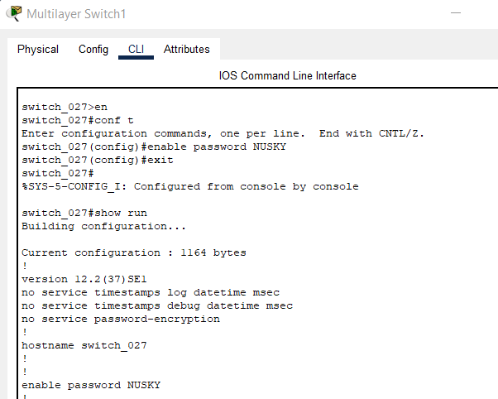



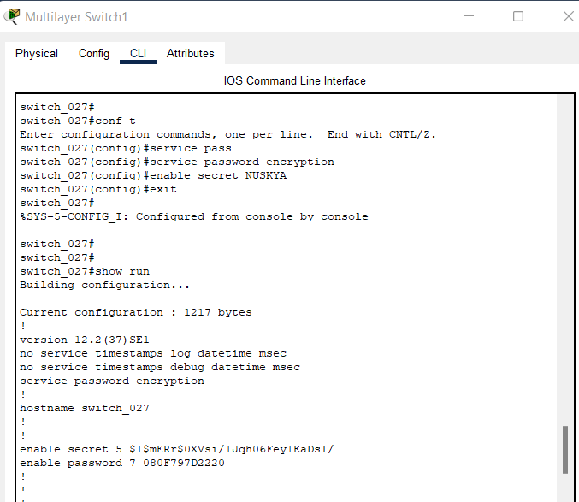



ROUTER

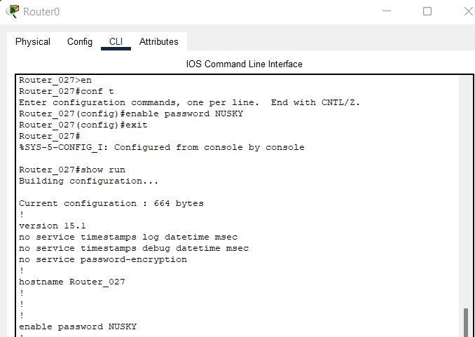



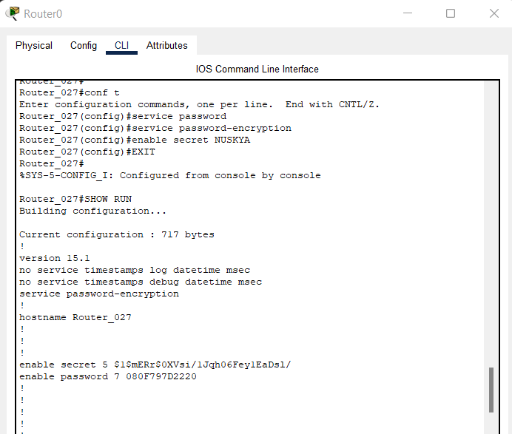



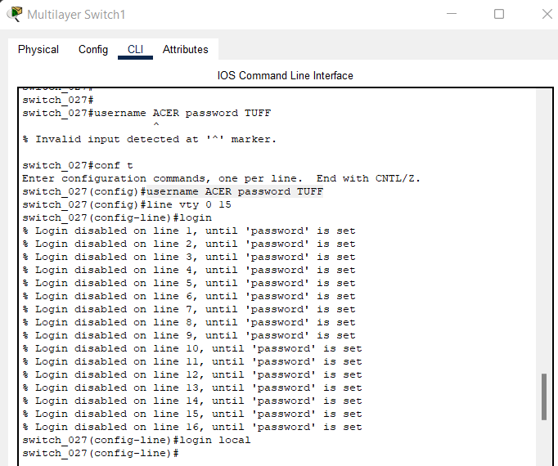

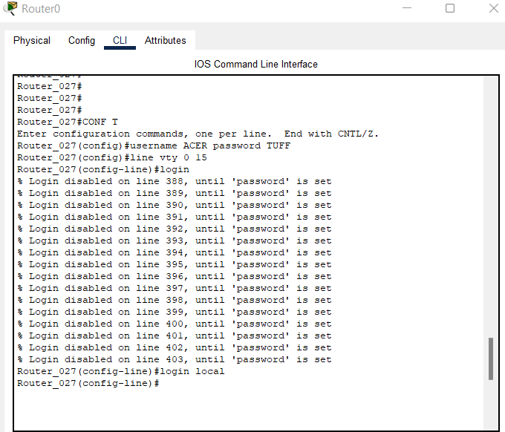

b. Configure AAA authentication for the console login to use the local user. Verify your

configurations on the switch.

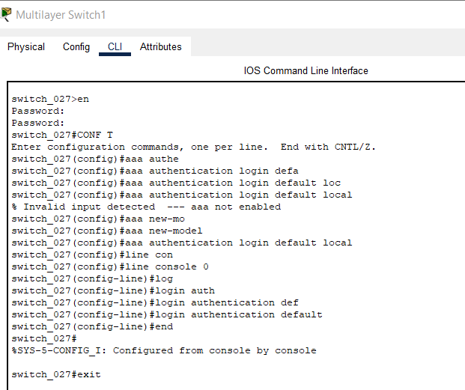

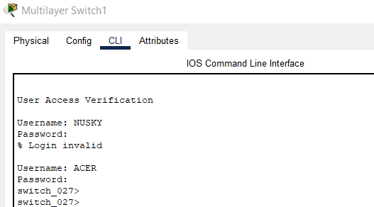

c. Enable only SSH as a connection method for line VTY.

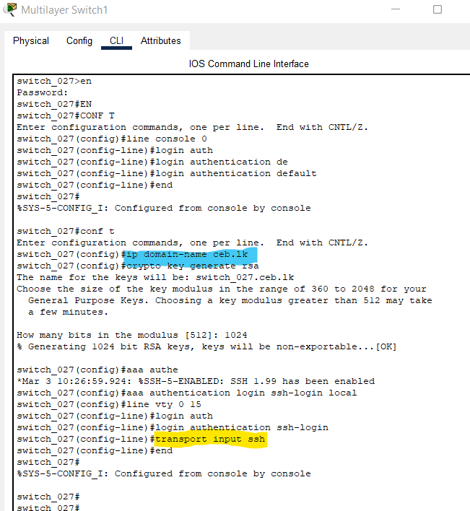

d. Configure RADIUS server based AAA authentication for VTY lines on the router.

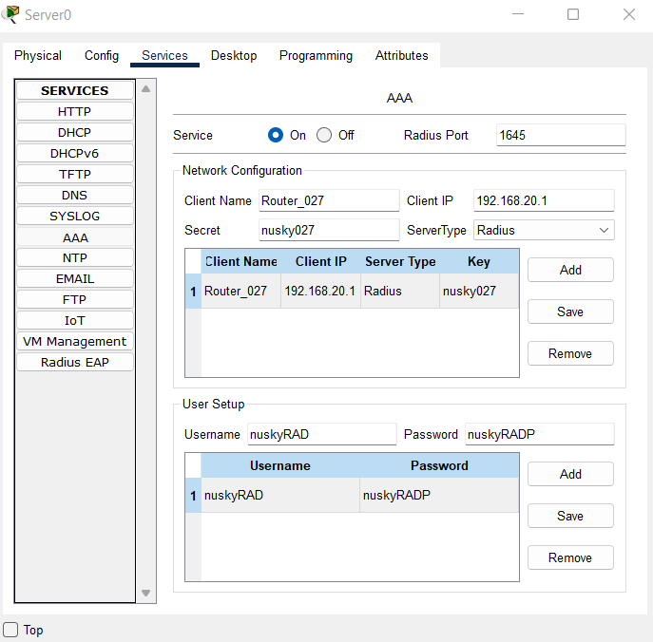

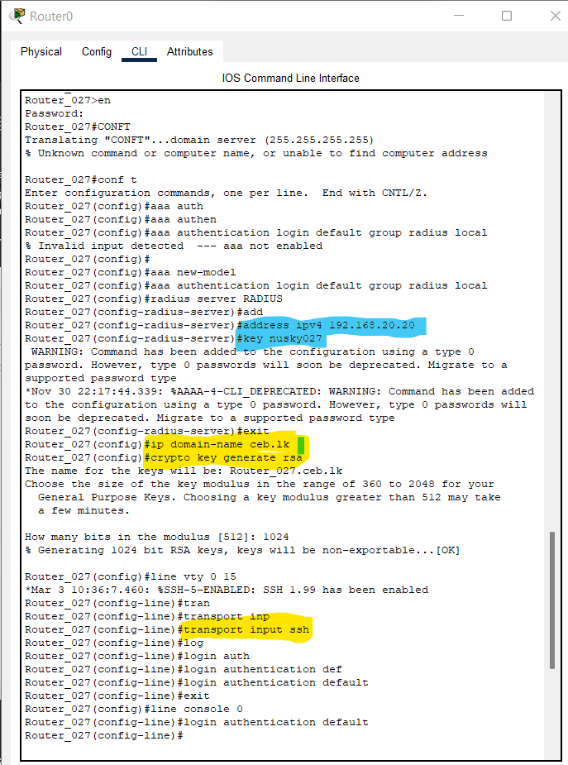

e. Verify the AAA configuration by establishing a connection to the router from the PC.

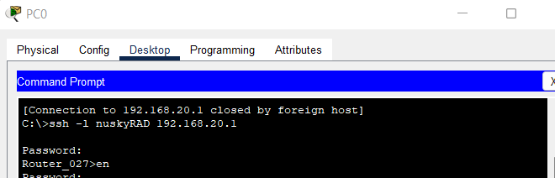

Using show run we can get the details like below

